THE SCUTTLEBUTT
ALL GAVE SOME, SOME GAVE ALL

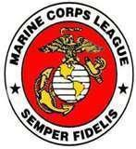

The Official Publication of the Stanly County Detachment 1021 Marine Corps League
P. O. Box 1111 Albemarle, NC 28002

Volume 18 L. D. Roush Issue 01 Editor

JANUARY, 2017

2016-2017 OFFICERS
Paul E. Hummel, Commandant
Senior Vice Commandant William T. Pressley
Junior Vice Commandant Russell T. Aronis
Past Commandant Edgar S. Watson
Judge Advocate Robert D. Jadlocki
Adjutant-Paymaster Gary L. Bryan
Chaplain Eli E. Galloway
Sergeant-at-Arms Larry L. Shoe

Historian Lawrence D. Roush
COMMANDANT’S COMMENTS
Marines,
As our Detachment gears-up for a new year I sincerely hope all of our Marine Family has had a wonderful Holiday Season and is enjoying good health.
The phrase HAPPY NEW YEAR can have different meanings to different people but for this Older and Wiser Commandant it is HOPE that our Detachment and their Families receive all that they so richly deserve.
2016 was a very successful year and I’m looking forward to a bright 2017. The regular scheduled meeting on 30 January, 2017 will be the chance to reminisce on the past years events and to present awards to our Toys for Tots supporters. Come out and welcome the wonderful folks that help make the program successful.
Hope to see ya’ll at the VFW Post # 2908 at 1900 hrs.
SEMPER FI.

Paul Hummel
Commandant

MARINE CORPS LEAGUE
STANLY COUNTY DETACHMENT 1021
REPORT OF BREAKFAST MEETING
DECEMBER 17, 2016

The quarterly breakfast on 17 December substituted for our Regular meeting scheduled for December 26. This meeting was primarily an opportunity to eat good food and enjoy good conversation. A description of what little business that was conducted follows:
Our special guests for this breakfast were Mark Shue and Henry Clontz of the Guardian Nomads Law Enforcement Motorcycle Club, a major supporter of our Toys for Tots program. The club’s 24 “September Ride” raised $771.25 for the program.
2016 MARINE OF THE YEAR
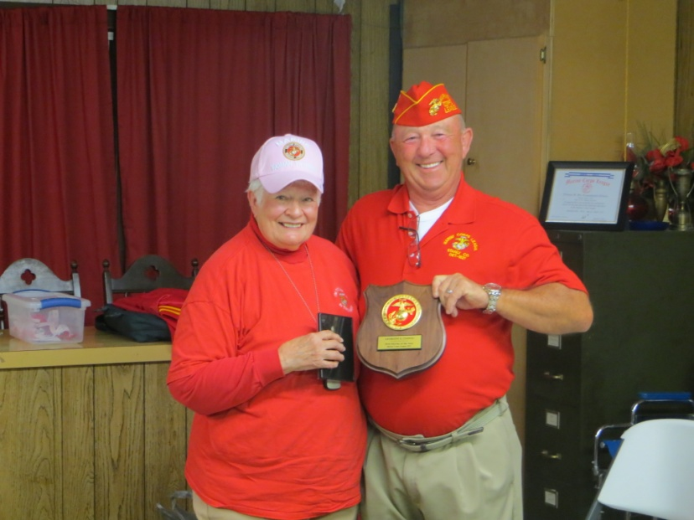
Commandant Hummel presents the 2016 “Marine of the Year” award to Marine Georgine Clontz.
Marine Clontz’s Outreach Program to Veterans of all branches residing in assisted living and other care facilities has given a ray of joy to many and additional recognition to the detachment.
Well Done Georgine!!
PAYMASTERS REPORT: Paymaster Bryan advises that a formal financial report for the period will be made to the membership at the January 30th meeting.
Note from the Paymaster: Members are reminded that the yearly dues are changing this year. If your dues become due between January and July this year you will owe $25.00 and you new expiration date will be August 2017. Effective 1 September 2017 all members, who are not Life Members, will owe their yearly dues of $35.00. National MCL instituted this change at the last National Convention and in the future all memberships will expire at the end of August, and annual dues will be due on 1 September. Any members wishing clarification of their particular situation or further information can call me at 704 986 0517 or email me at gbryan3340@aol.com.

Toys for Tots: Since the 17 December Meeting Marine Pressley has completed the After Action Report for Toys for Tots HQ. The report is reproduced as follows:
Toys For Tots After Action Report 2016
Beginning Balance $ 755.44
Foundation (Bojangles) $ 6,375.00
Toys R US $ 1,000.00
Motorcycle Ride $ 771.25
Donations- Individuals $ 250.00
“ Wedding $ 200.00
“ Money Cans $ 362.87
Memory of Davie Victor Williamson $ 355.00
Refund $ 46.98
Total $ 10,116.54
Spent $ 8,209.87
Other (Golf Balls, Tape) $ 143.20
Remaining Balance $ 1,716.49

Number Toys Donated 1,950
“ “ Purchased 581
“ “ from Foundation 1,072
“ “ Distributed 3,720
Number of Children ReceivingToys 1,207
GOOD OF THE LEAGUE:
SPECIAL NOTE:
Rick Thomason, Adjutant, Department of North Carolina, Mid East Division, Marine Corps League has requested that all Marines be made aware of the following information.
VA Plans to Approve Benefits for Veterans Exposed to Contaminated Water at Camp Lejeune
WASHINGTON:
The Department of Veterans Affairs (VA) announced today that it plans to propose expanded disability compensation eligibility for Veterans exposed to contaminated drinking water while assigned to Marine Corps Base Camp Lejeune 1953 to 1987.
Water sources at Camp Lejeune were contaminated from 1953 till 1987 with industrial solvents that are correlated with certain health conditions.
Secretary of Veterans Affairs, Robert A. McDonald, decided to propose presumptions of service connection for certain conditions associated with these chemical solvents following discussions between environmental health experts at the Veterans Health Administration and the Department of Health and Human Services Agency for Toxic Substances and Disease Registry (ATSDR).
“The water at Camp Lejeune was a hidden hazard, and it is only years later that we know how dangerous it was,” said Secretary McDonald.
“We thank ATSDR for the thorough review that provided much of the evidence we needed to fully compensate Veterans who develop one of the conditions known to be related to exposure to the compounds in the drinking water.”
ATSDR:
This agency determined that the drinking water at Camp Lejeune was contaminated with perchloethy- lene, trichloroethylene, vinyl chloride, benzene and other petroleum contaminants from leaking storage tanks from 1953 to 1987. ATSDR also determined that prolonged exposure to these chemicals increases the risk of certain health conditions.
Based upon VA’s review of current medical science and ATSDR’s findings, Secretary McDonald intends to propose creation of a presumption of service connection for the following conditions:
· Kidney Cancer
· Liver Cancer
· Non-Hodgkin Lymphoma
· Leukemia
· Multiple Myeloma
· Scleroderma
· Parkinson's Disease
· Aplastic Anemia / Myelodysplastic Syndromes.
Th The Secretary’s proposal would also expand benefits eligibility to Reserve and National Guard personnel who served at Camp Lejeune for any length of time from August 1, 1953, through December 31, 1987.
These personnel would be presumed to have been exposed to the contaminated water during their Reserve or National Guard service and, in appropriate circumstances, to have been disabled by such exposure during service, thus allowing them to qualify for VA benefits under the statutory definition of “Veteran.”
This would make them eligible for VA disability compensation and medical care for any of the presumptive conditions, and their surviving dependents would be eligible for dependency and indemnity compensation and burial benefits.
VA is working on regulations that would establish these presumptions, making it easier for affected Veterans to receive VA disability compensation for these conditions.
While VA cannot grant any benefit claims based on the proposed presumption of service connection for these conditions until it issues its final regulations, it encourages Veterans who have a record of service at Camp Lejeune between August 1, 1953, and December 31, 1987, and develop a condition that they believe is related to exposure to the drinking water at the base, to file a disability compensation claim with VA.
VA will continue to grant claims for disabilities claimed to be associated with exposure to the contaminants that can be granted under current regulations and review of the evidence in each case.
If a claim for service connection for one of the proposed presumptive conditions would be denied under current regulations, the denial will be stayed until VA issues its final regulations.
VA will announce when the regulations are final and presumptive benefits can begin to be awarded.
Veterans who served at Camp Lejeune for 30 days or more between August 1, 1953, and December 31, 1987, are already eligible to receive VA healthcare for up to 15 health conditions.
VA is reimbursing certain veterans’ family members for eligible out-of-pocket medical expenses related to the 15 covered conditions.
WANTED A FEW GOOD MARINES
Not infrequently there is a need to inform members of events (i.e. funerals, work parties, previously announced date changes or cancellations) which are too close in time to allow for regular mail notification of all members.
A procedure has been developed to meet this need. In short when I receive notice of a item of interest to All hands I will e mail the members with email. One member with email will then call one member without email and orally provide the information.
Currently only 7 members have volunteered for this project.
The Following is a list of members without email and their telephone numbers: the member volunteering to call a particular member is printed in bold. Please consider volunteering for this service and let me know who is calling who.
Claude Brooks – 704-888-4678 or 704-328-0879 Pressley
George Burleson 704-983-1841
Danny Burris 704-485-4960 or 704-322-0078
Rickey Burris 704-485-2094 Bryan
Hilton Butler 704-982-5858
Georgeine Clontz 980-328-0171 Roush
Eli Galloway 704-982-7056 York
Wiley Helms (?)
Robert Jadlocki 704-982-9719 Arronis
Charles Jordan 704-463-191 Shoe
Jerry Lambert 704-463-1191
Charles Lemons 704-981-4098
Jerry Measmer 704-463-1191
Christopher Nash (?)
Jeffery Nash 704-982-7381
Michael Oliver (?)
Justin Pugsley 704-474-0491
Rickey Thompson (?)
Ronny Tucker 704-485-2726 Watson

Corrections welcome

Semper Fidelis
L. D. Roush
THIS MONTH IN MARINE CORPS HISTORY
FROM: MARINE CORPS RESERVE ASSOCIATION
10 January 1995: The Pentagon announced that 2,600 U.S. Marines would be deployed to Somalia for Operation United Shield to assist in the final withdrawal of UN peacekeeping troops from Somalia.
11 January 1945: The first elements of Marine Aircraft Group 24, commanded by Colonel Lyle H. Meyer, landed at Lingayen, Luzon, Philippine Islands, to provide close air support for Army forces. Over the next three months, MAG-24 and MAG-32 would fly a total of 8,842 combat sorties and drop more than 19,000 bombs as part of the Fifth Air Force in support of the Sixth Army.
18 January 1951: Marines of the 1st Marine Division began mopping-up operations against guerrillas in the Pohang area, South Korea, following the Division's return from its epic battle with Communist Chinese troops at the Chosin (Changjin) Reservoir.
20 January 1968: The second battle for Khe Sanh began when Marines from the 3d Battalion, 26th Marines attacked a North Vietnamese battalion between Hill 881 South and Hill 881 North. More than 100 of the enemy were killed.
21 January 1918: The 1st Aeronautical Company arrived at Ponta Delgada, Azores, for anti-submarine duty. That unit was one of the first completely equipped American aviation units to serve overseas in World War I.
22 January 1969: Operation Dewey Canyon, perhaps the most successful high-mobility regimental-size action of the Vietnam War, began in the A Shau/Da Krong Valleys when the 9th Marines, commanded by Colonel Robert H. Barrow, and supporting artillery were lifted from Quang Tri. By 18 March the enemy's base area had been cleared out, 1617 enemy dead had been counted, and more than 500 tons of weapons and ammunition unearthed.
25 January 1856: Marines and seamen from the U.S. sloop Decatur went ashore at the village of Seattle, Washington, to protect settlers from Indian raids. The Indians launched a seven-hour attack but were driven off later that day after suffering severe losses. Incredibly, only two civilian volunteers were killed and no Marines or sailors were lost.
27 January 1988: About 400 Marines and sailors from the 2d Marine Division, 2d Marine Aircraft Wing, and 2d Force Service Support Group deployed for the Persian Gulf. The Contingency Marine Air-Ground Task Force (MAGTF) CM 2-88 would relieve Contingency MAGTF 1-88 in the volatile Persian Gulf and provide the effective landing force capability to Joint Task Force Middle East.
29 January 1991: The first serious ground fighting of Operation Desert Storm broke out when Iraqi troops mounted an attack into Saudi Arabia along a 40-mile front. Iraqi units centered their efforts on Khafji, a port city six miles south of the border. Saudi and Quatari troops, supported by artillery from the 1st Marine Division and attack helicopters and other allied coalition aircraft, recaptured the town two days later.

